CSCI 2720 Building Web Applications

Group 5 Report

LEUNG Pui Ying MO Sheung TANG Yuk Yee ZHUMAGALEYEV Alikhan

**Abstract**  
In this report, we will present our project's workflow and its main components. This project focuses on solving the challenge of simplifying cultural event management for users and administrators. It provides functionalities such as map browsing, program searching, and admin control, ensuring a seamless Single Page Application (SPA) experience.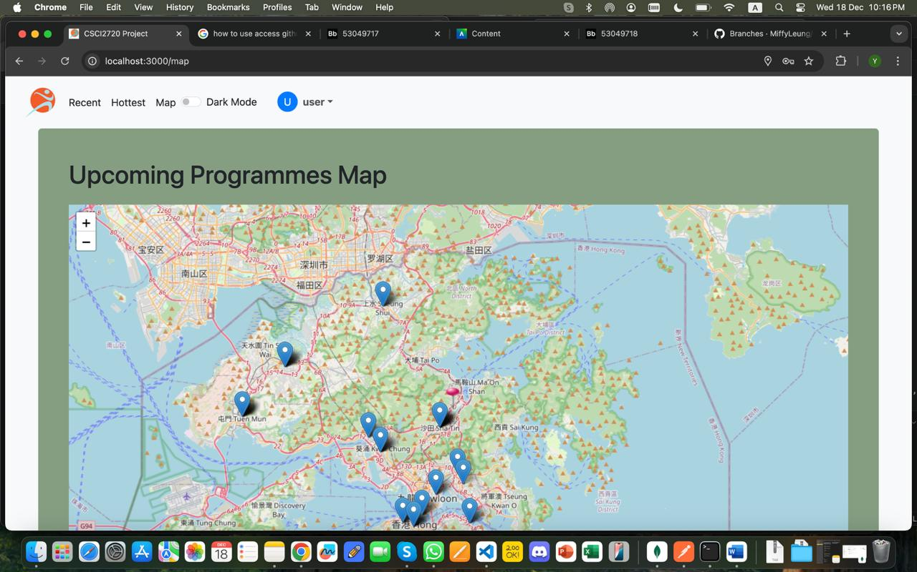

**Methodologies**

File list

This project uses separate folder structures for the frontend and backend for modular development:

**Frontend**: Built using ES modules (Typescript) to leverage tree-shaking and smaller bundle sizes. This ensures compatibility with modern browsers and front-end frameworks like React.

**Backend**: Utilizes CommonJS modules (Javascript) for maximum compatibility with Node.js and existing middleware packages.

To streamline development, the concurrently library is used to run both frontend and backend servers simultaneously, improving efficiency during iterative development.

Pre-processing of the dataset

This project uses publicly available real-world data from the following dataset:

**Dataset**: Cultural Programmes [1]

The dataset contains information about cultural programs, including details like program titles, venues, dates, descriptions, and presenters.

Required actions

**Main login page 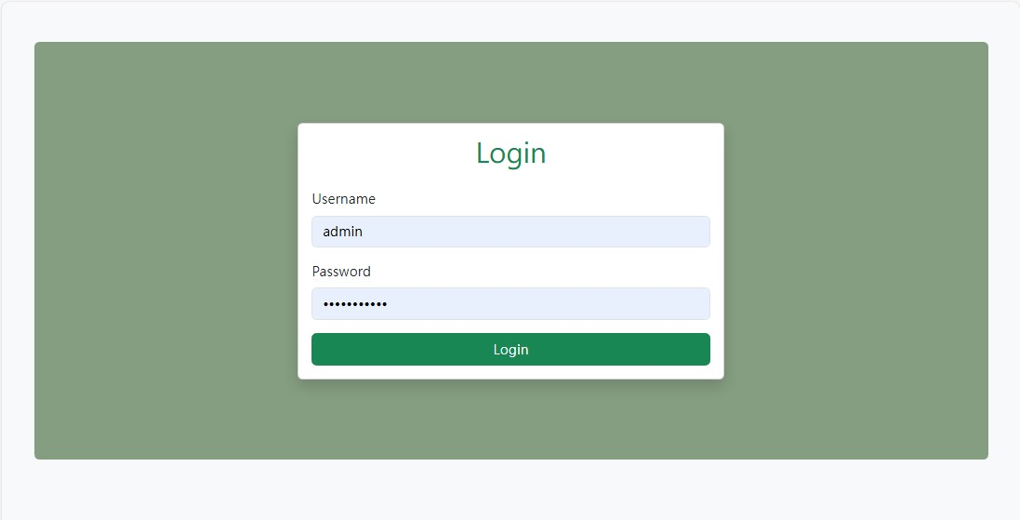**For testing, you can use ***admin*** / ***user*** as username and ***password123*** to login  
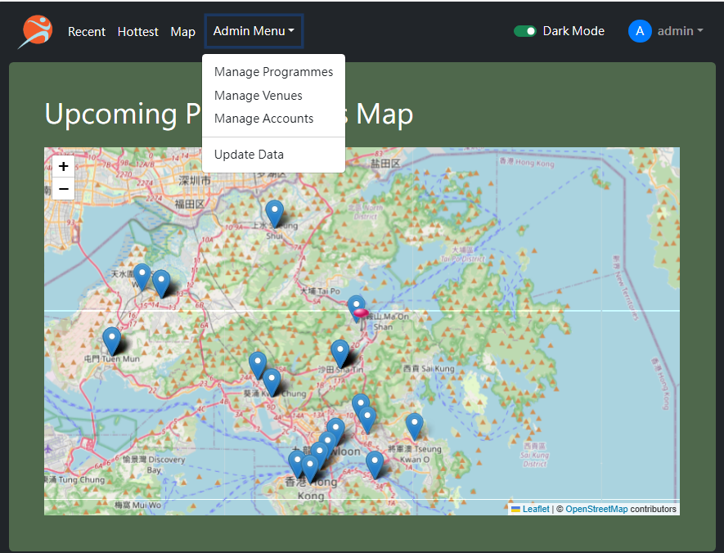  
Login page for users to have different access levels such as admin and normal users

***Non-user actions:***

Login as Users – only authenticated users can access the app’s contents. A user is recognized using a username and password pair. The user will be able to perform the “user actions”,

Login as Admins – admins will be able to perform arbitrary CRUD actions to the location data

and the user data on your database.

**User view**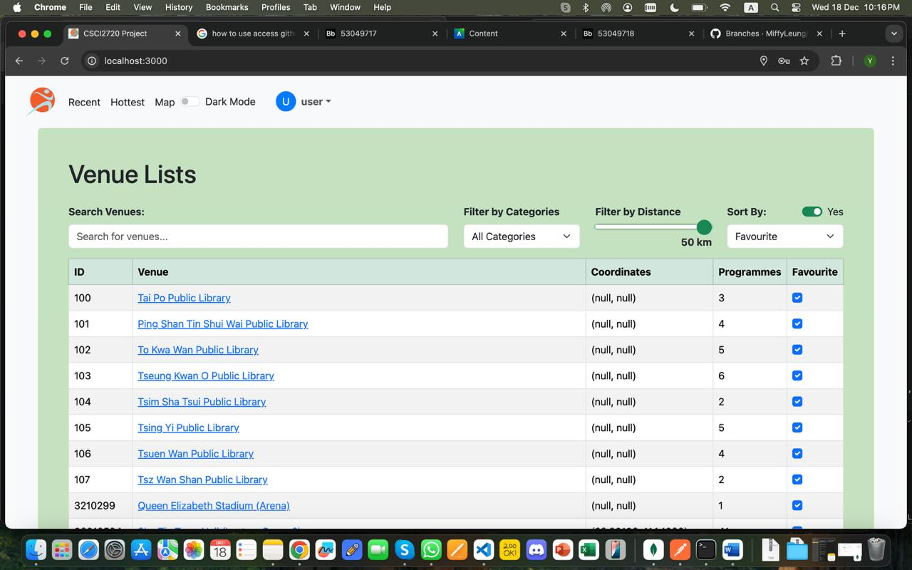

listing all locations in a table as links to single locations and allow sorting of the table

with filters like the number of events at the venue.  
  
Show all locations on a map, with links to each single location

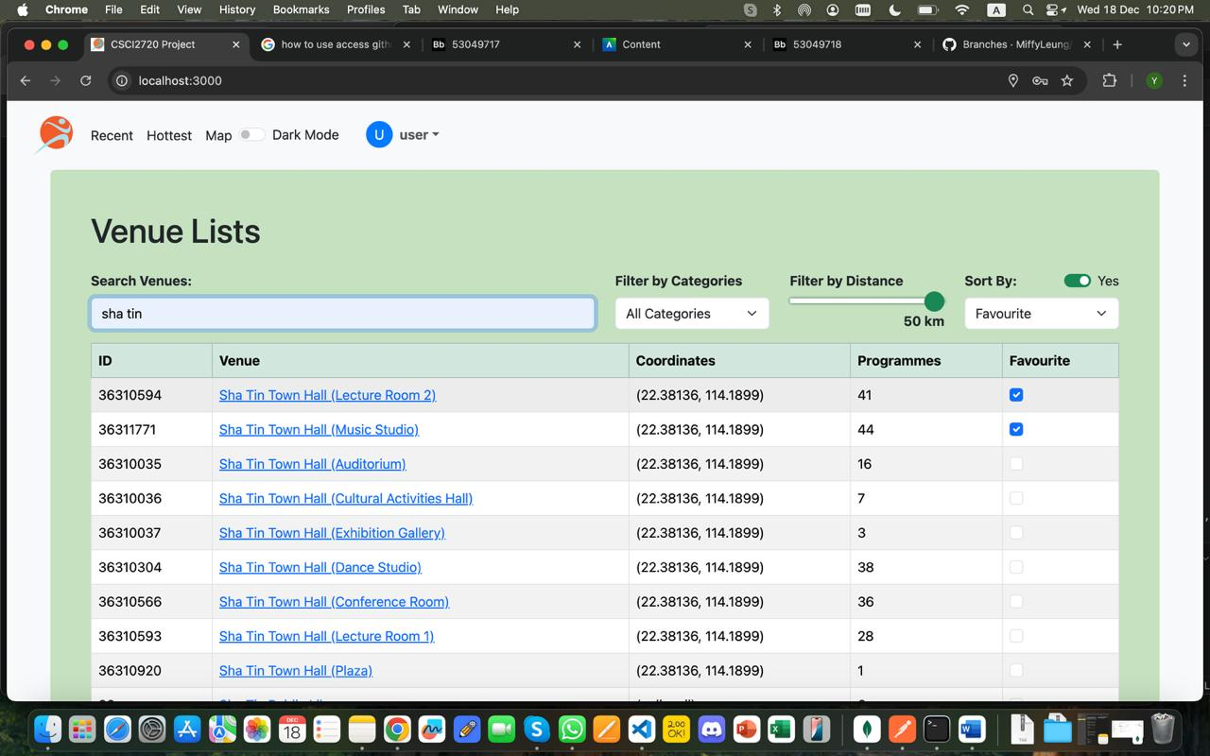

Search for locations that contain keywords in the name which will result in a table of

location results. Filter locations by program category, and distance (e.g., within x km), with dynamic updates to the location list and map without page refresh

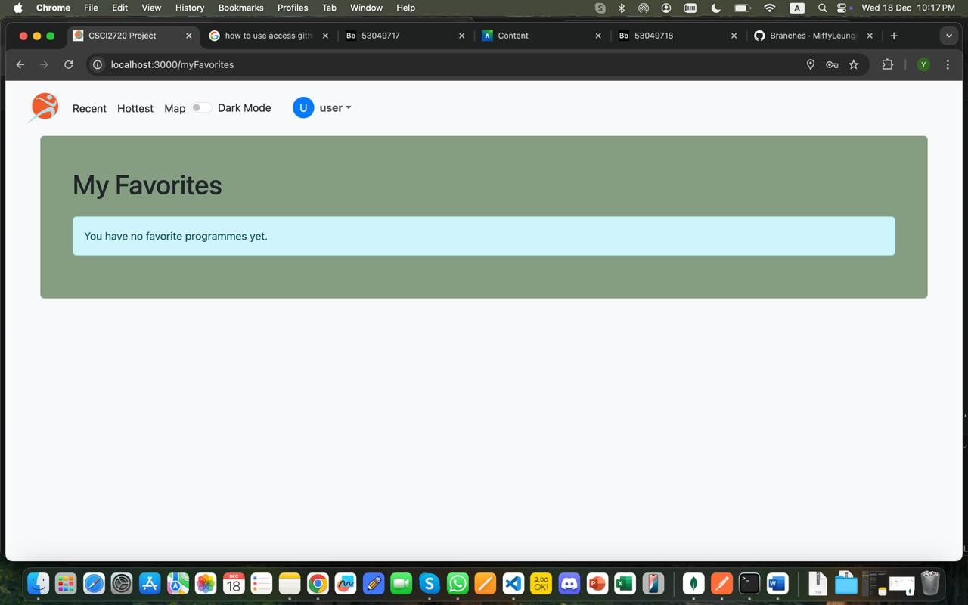  
You can add a location to a list of the user’s favorite locations and see the list in another view. 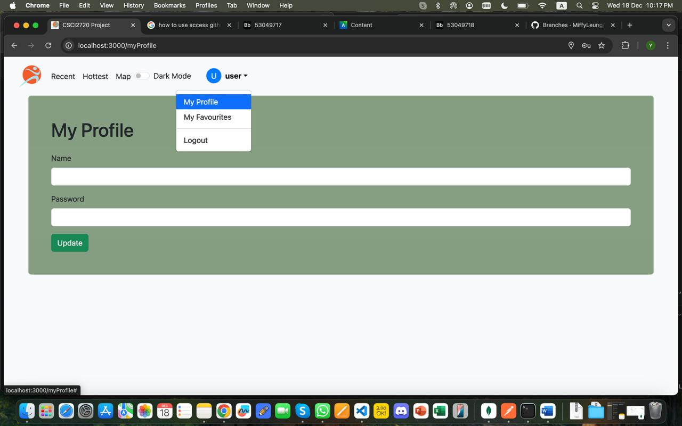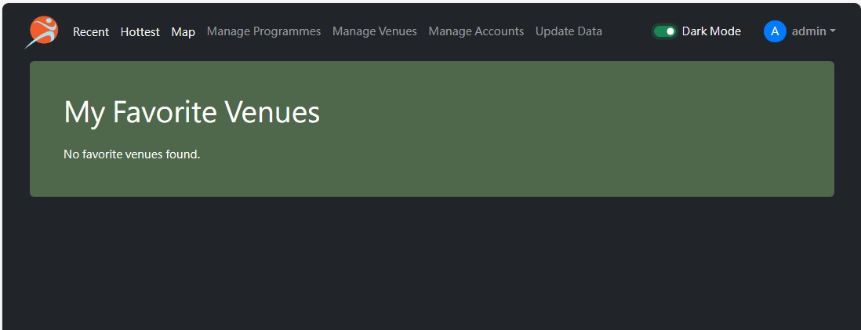To log out, see the username at the top-right of the screen.

**Admin view**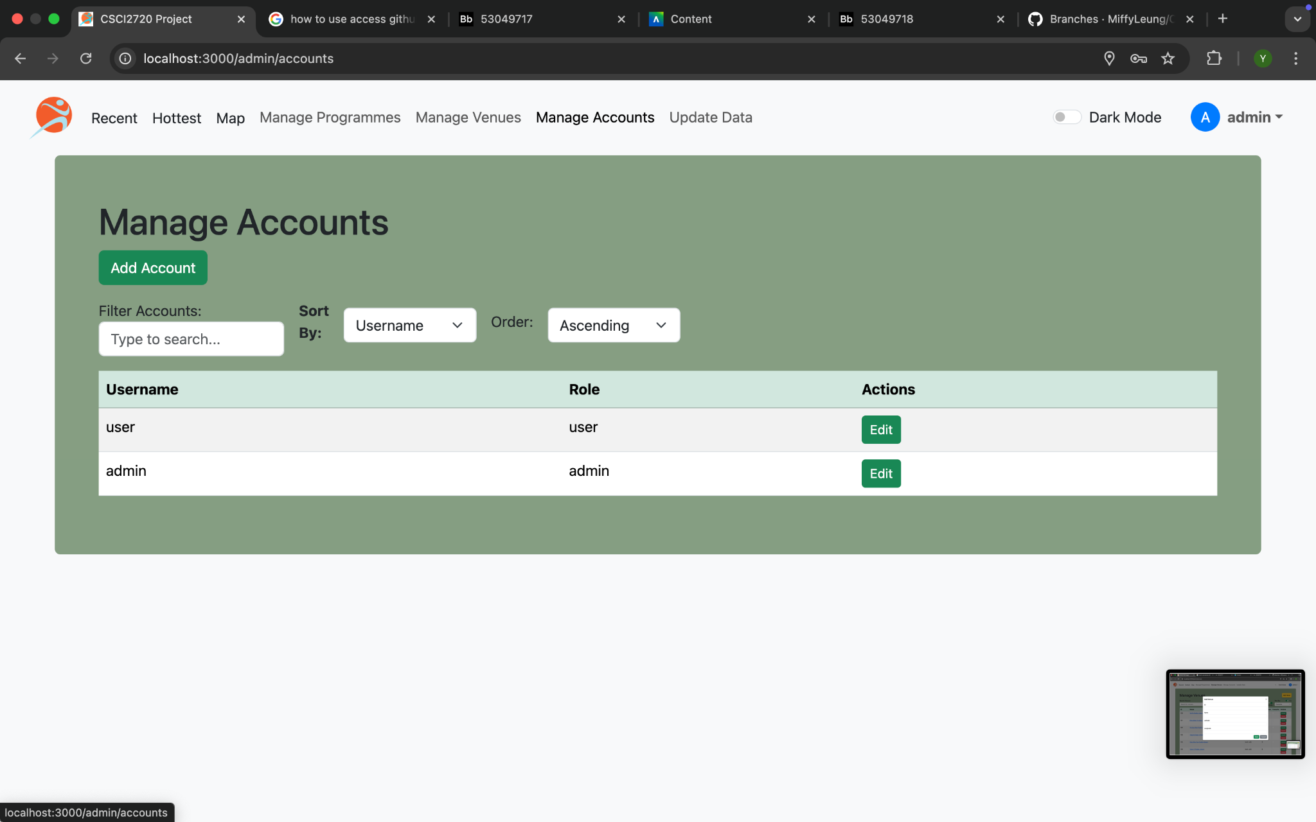

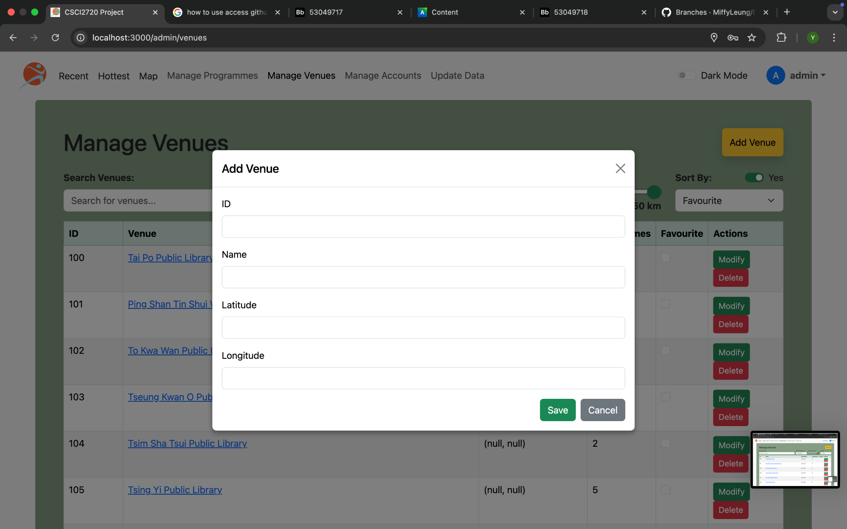

Able to CRUD user data (username and password only) in the local database.

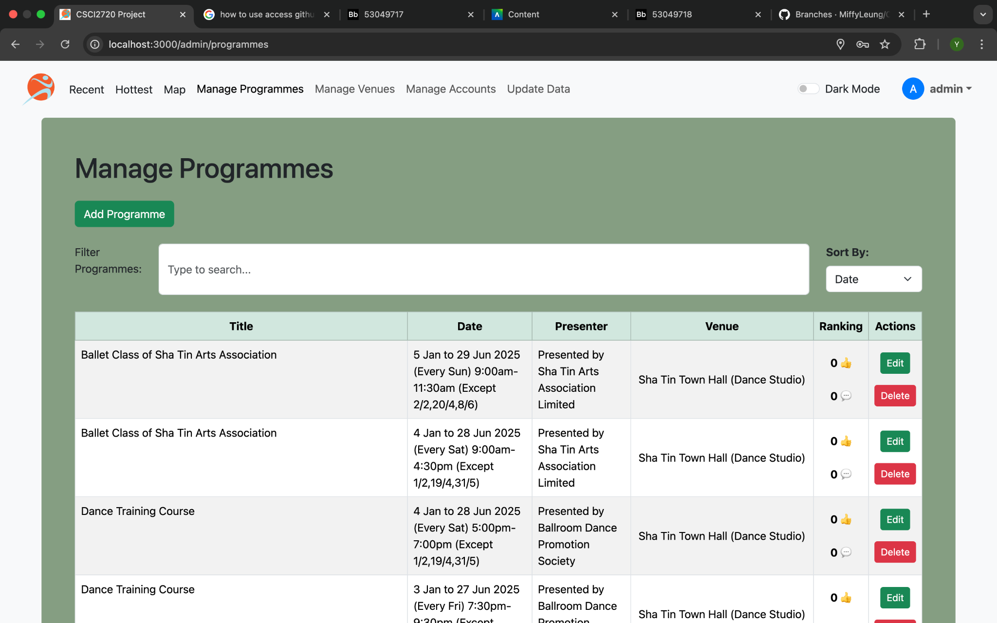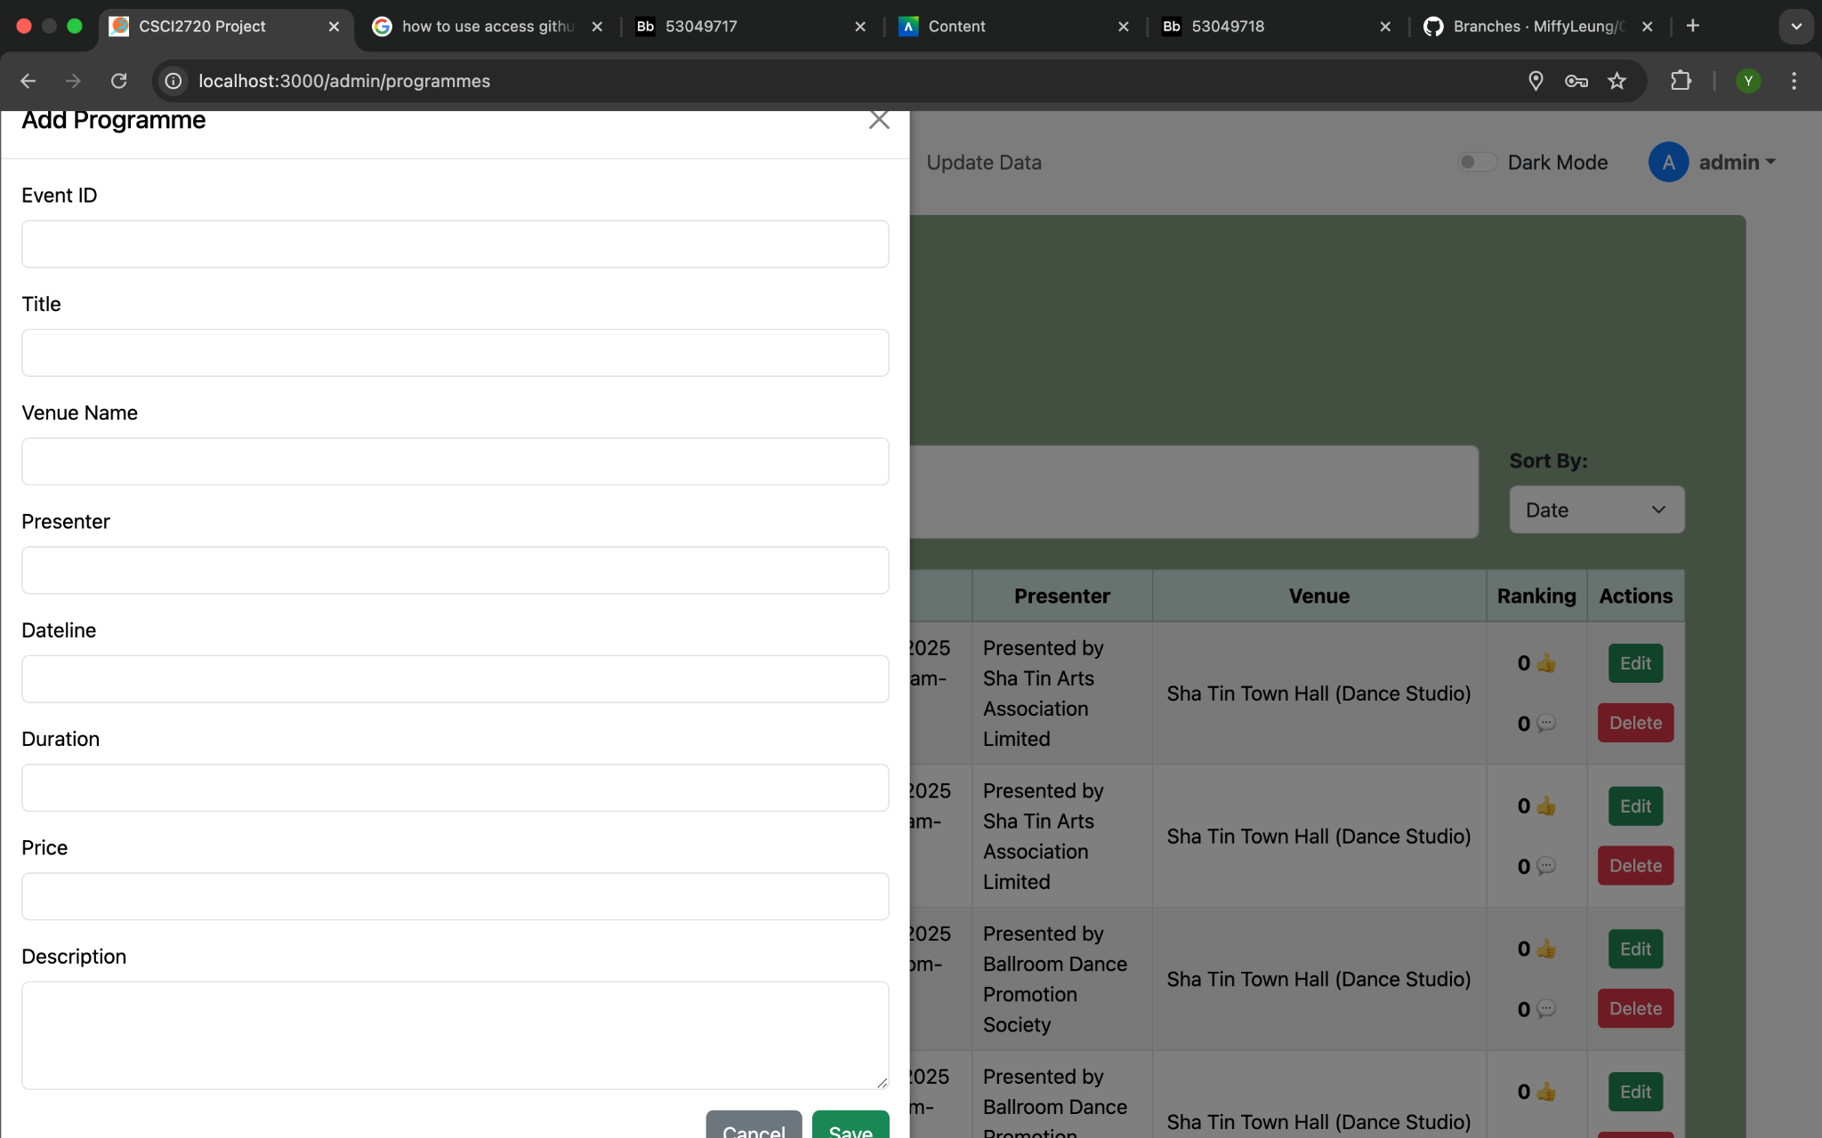Able to CRUD stored event details in the local database.  
See the username in the top-right of the screen and be able to log out as admin

**Bouns features**

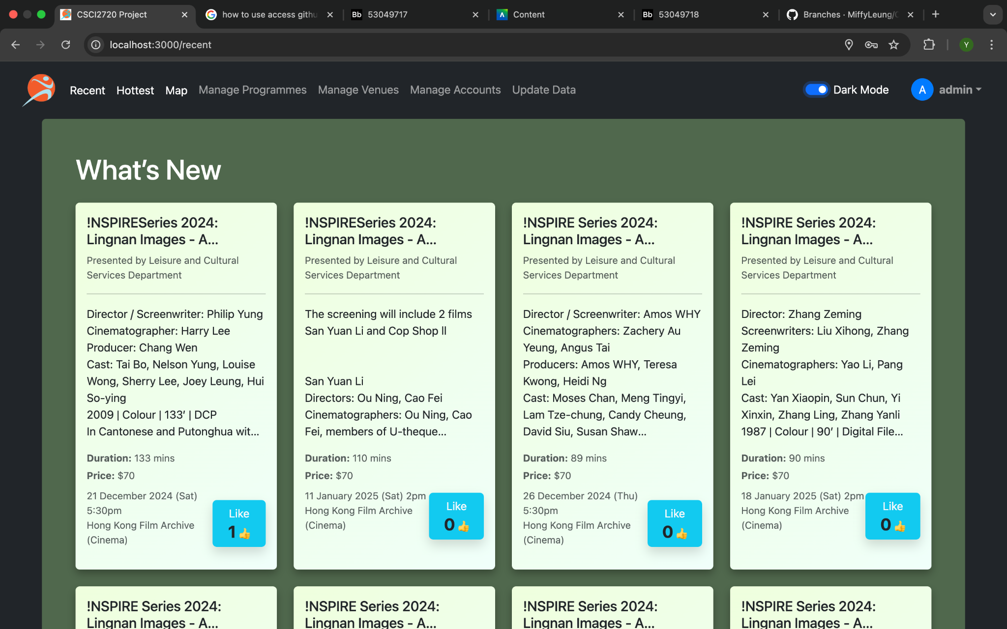

Dark light mode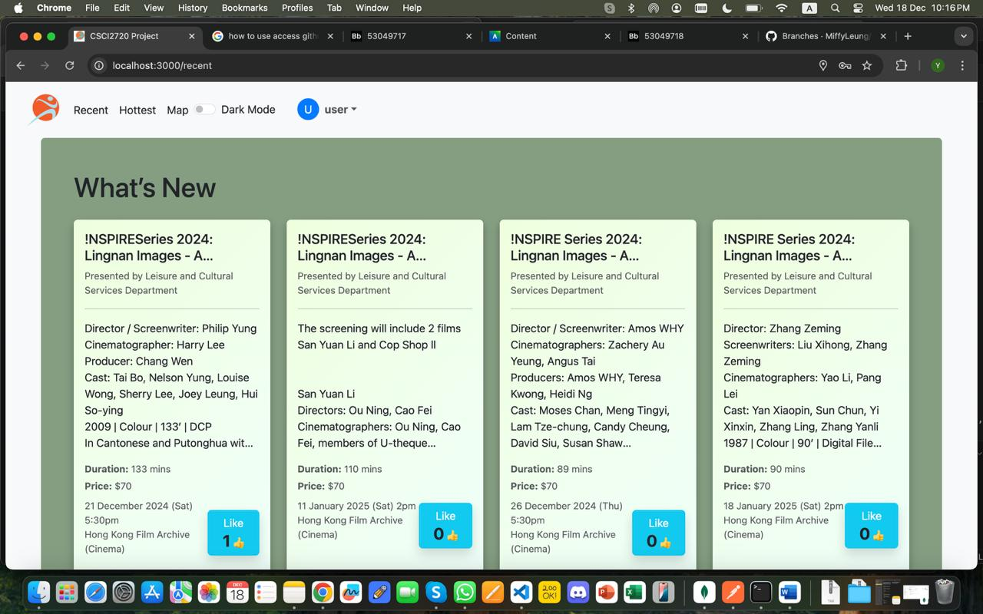Like button on “What’s new”.

**Important algorithms/functions/components we used**

Map API: Leaflet.js

The primary reason we chose Leaflet is that it is an open-source map library that does not require an API key or account registration, in contrast to Google Maps and Mapbox, which both require a credit card for free accounts.

Utilities: Concurrently

We use Concurrently to simultaneously run both the frontend and backend servers, simplifying development workflows.

**Design of data schemas**

Package Components: Most visual components are replaced with React components, stored in frontend/src/components/ for easy reuse and maintainability.

Centralize Field Metadata: The structure and initial state of various data fields are centralized in frontend/src/types/.

Select Module Versions Carefully: Modules are carefully selected and versions are strictly controlled to reduce conflicts and ensure compatibility.

**Models of database**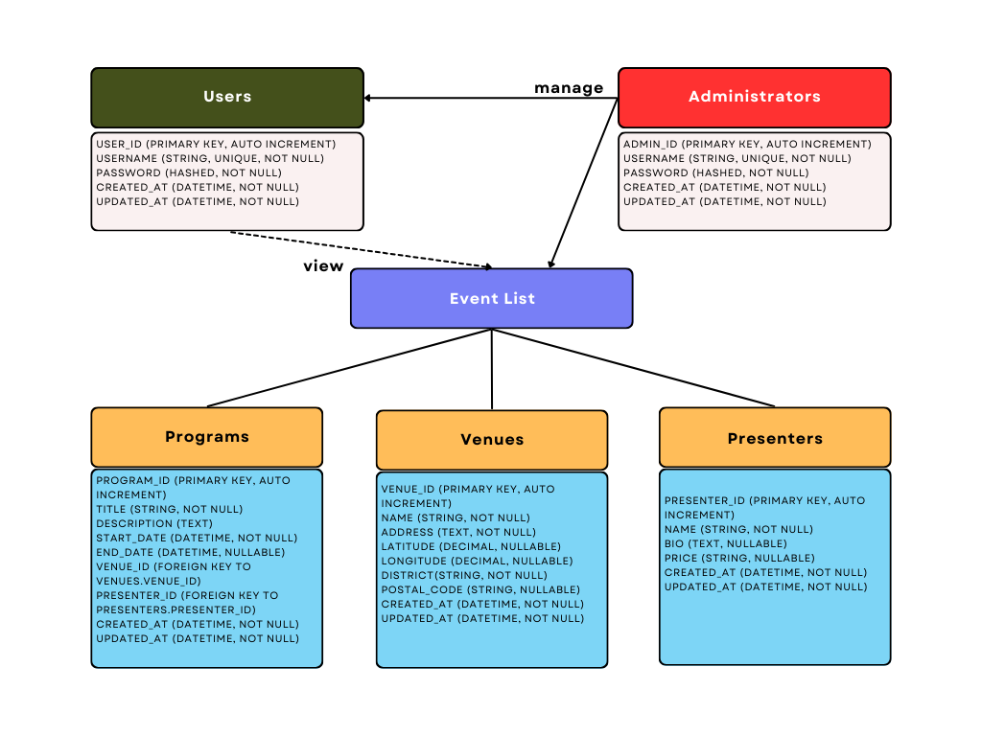

# **Bibliography**

[1]

“Cultural Programmes | DATA.GOV.HK,” *data.gov.hk*. https://data.gov.hk/en-data/dataset/hk-lcsd-event-event-cultural